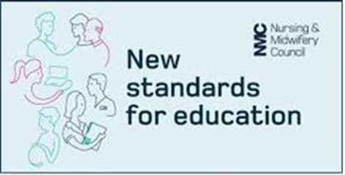
The new standards separate out supervision and assessment, and students are assigned to a practice supervisor, practice assessor and an academic assessor.
Practice supervisors can be any registered health and social care professional and can contribute to the student’s record of achievement.
Practice assessors obtain feedback from practice supervisors and others to assess the student.
Academic assessors liaise with the practice assessor to agree practice assessment decisions.
The future nurse
The Nursing & Midwifery Council (NMC) has reviewed and updated the standards of proficiency for nurses and the standards for education and training.
These reflect the changing needs for the role nurses will play in future healthcare services.
Midwifery standards will also be developed in the near future.
Students on all four fields will be required to meet annexe A: communication and relationship management skills. A greater depth of knowledge and more advanced skills are required to care for people in the students chosen field of practice.
Students on all four fields will be required to meet annexe B: nursing procedures. This includes venepuncture, ECGs, mental health assessment/ exposure, chest auscultation and interpreting results from these. A greater depth of knowledge and more advanced skills are required to care for people in the students chosen field of practice.

will be expected to develop a wide range of technical skills including venepuncture, cannulation and blood sampling.
Newly qualified registrants can access the community practitioner nurse prescribing course (V150) straight away if seen as an organisational service need. Qualified nurses will be able to access the independent/supplementary prescribing programme (V300) after one years’ experience.
Programme content
The Future Nurse standards apply across all four fields and all care settings. All registered nurses are expected to be able to meet the person-centred, holistic care needs of people at any stage of life who may have a range of mental, physical, cognitive or behavioural health challenges.
Standard supervision & assessment
There are revised definitions of supernumerary status, and the level of supervision can decrease as the student’s proficiency and confidence increases.
Students can undertake clinical procedures to provide person-centred care without direct oversight once they are proficient.
Supervisors and assessors will be required to self-declare against the NMC standards, and there will be a range of resources available to upskill staff to meet the outcomes. Organisations will assign appropriate professionals to carry out each of these roles within practice placements.
Organisations will monitor and provide ongoing support for persons undertaking these roles.
The new standards have seven platforms:
1234567Being an accountable professional

Promoting health and preventing ill healthAssessing needs and planning careProviding and evaluating careLeading and managing nursing care and working in teamsImproving safety and quality of careCo-ordinating care
The new standards have a greater emphasis on leadership, multi-disciplinary working and working across different settings.
All programmes offered by all Approved Education Institutions (AEIs) must be aligned to the new standards by September 2020. AEIs in the North West plan to adopt these new standards from September 2019.

Key changes to the Standards for Pre-Registration Nurse Education
Greater Manchester
Practice Education Facilitator's Forum

Greater Manchester
Practice Education Facilitator's Forum

Greater Manchester
Practice Education Facilitator's Forum

Greater Manchester
Practice Education Facilitator's Forum

